**PIZZA SALES SQL QUERIES**

**A. KPI’s**

**1. Total Revenue:**

SELECT SUM(total_price) AS Total_Revenue FROM pizza_sales;  
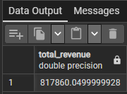  
**2. Average Order Value**

SELECT SUM(total_price)/COUNT(DISTINCT order_id) AS Average_Order_Value

FROM pizza_sales  
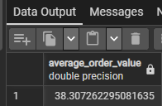

**3. Total Pizzas Sold**

SELECT SUM(quantity) AS Total_Pizzas_Sold FROM pizza_sales  
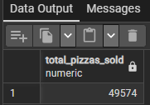

**4. Total Orders**

SELECT COUNT(DISTINCT order_id) AS Total_Orders FROM pizza_sales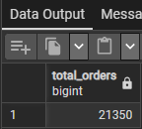

**5. Average Pizzas Per Order**

SELECT CAST(CAST(SUM(quantity) AS DECIMAL(10,2))/CAST(COUNT(DISTINCT order_id)

AS DECIMAL(10,2)) AS DECIMAL(10,2)) AS Average_Pizza_Per_Order FROM pizza_sales

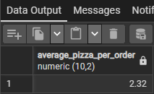

**B. Daily Trend for Total Orders  
SELECT TO_CHAR(order_date, 'Day') AS order_day,**

**COUNT(DISTINCT order_id) AS total_orders FROM pizza_sales**

**GROUP BY TO_CHAR(order_date,'Day'), EXTRACT(DOW FROM order_date)**

**ORDER BY EXTRACT(DOW FROM order_date)**

***Output:***

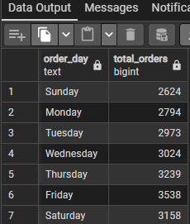

**C. Monthly Trend for Orders**

SELECT TO_CHAR(order_date, 'Month') AS order_month,

COUNT(DISTINCT order_id) AS total_orders FROM pizza_sales

GROUP BY TO_CHAR(order_date,'Month'), EXTRACT(MONTH FROM order_date)

ORDER BY EXTRACT(MONTH FROM order_date)

***Output:***

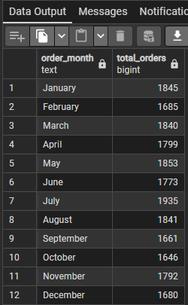

**D. % of Sales by Pizza Category**

SELECT pizza_category,

ROUND(CAST(SUM(total_price) * 100.0 / (SELECT SUM(total_price) FROM pizza_sales) AS numeric), 2) AS sales_percentage

FROM pizza_sales

GROUP BY pizza_category

ORDER BY sales_percentage DESC;  
***Output***

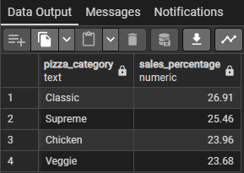

**E. % of Sales by Pizza Size**

SELECT pizza_size,

ROUND(CAST(SUM(total_price) * 100.0 / (SELECT SUM(total_price) FROM pizza_sales) AS numeric), 2) AS sales_percentage

FROM pizza_sales

GROUP BY pizza_size

ORDER BY sales_percentage DESC;  
***Output***

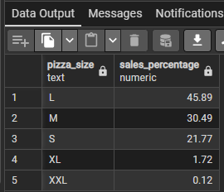

**F. Total Pizzas Sold by Pizza Category**

SELECT pizza_category, SUM(quantity) AS Total_Quantity_Sold

FROM pizza_sales

GROUP BY pizza_category

ORDER BY Total_Quantity_Sold DESC;  
***Output***

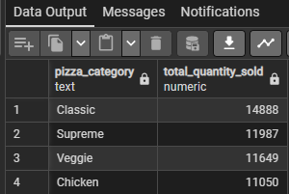

**G. Top 5 Pizzas by Revenue**

SELECT pizza_name,

SUM(total_price) AS total_revenue FROM pizza_sales

GROUP BY pizza_name

ORDER BY total_revenue DESC

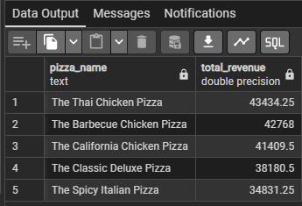

**H. Bottom 5 Pizzas by Revenue**

SELECT pizza_name,

SUM(total_price) AS total_revenue FROM pizza_sales

GROUP BY pizza_name

ORDER BY total_revenue ASC

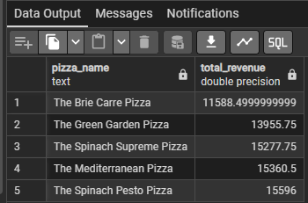

**I. Top 5 Pizzas by Quantity**

SELECT pizza_name,

SUM(quantity) AS Total_pizza_sold FROM pizza_sales

GROUP BY pizza_name

ORDER BY Total_pizza_sold DESC

LIMIT 5;  
***Output***

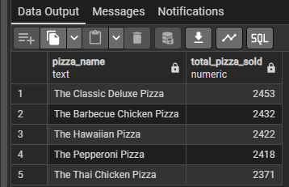

**J. Bottom5 Pizzas by Quantity**

SELECT pizza_name, SUM(quantity) AS Total_Pizzas_Sold FROM pizza_sales

GROUP BY pizza_name

ORDER BY Total_Pizzas_Sold ASC

LIMIT 5  
***Output***

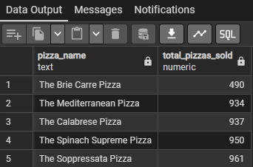

**K. Top 5 Pizzas by Total Orders**

SELECT pizza_name, COUNT(DISTINCT order_id) AS Total_Orders FROM pizza_sales

GROUP BY pizza_name

ORDER BY Total_Orders DESC  
LIMIT 5;

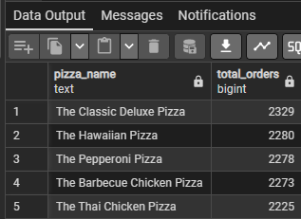

**L. Borrom 5 Pizzas by Total Orders**

SELECT pizza_name, COUNT(DISTINCT order_id) AS Total_Orders FROM pizza_sales

GROUP BY pizza_name

ORDER BY Total_Orders ASC  
LIMIT 5

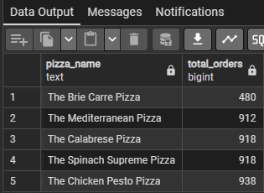

***NOTE***

If you want to apply the pizza_category or pizza_size filters to the above queries you can use WHERE clause. Follow some of below examples

SELECT pizza_name,COUNT(DISTINCT order_id)AS Total_Orders

FROM pizza_sales

WHERE pizza_category ='Classic'

GROUP BY pizza_name

ORDER BY Total_Orders ASC

LIMIT 5;